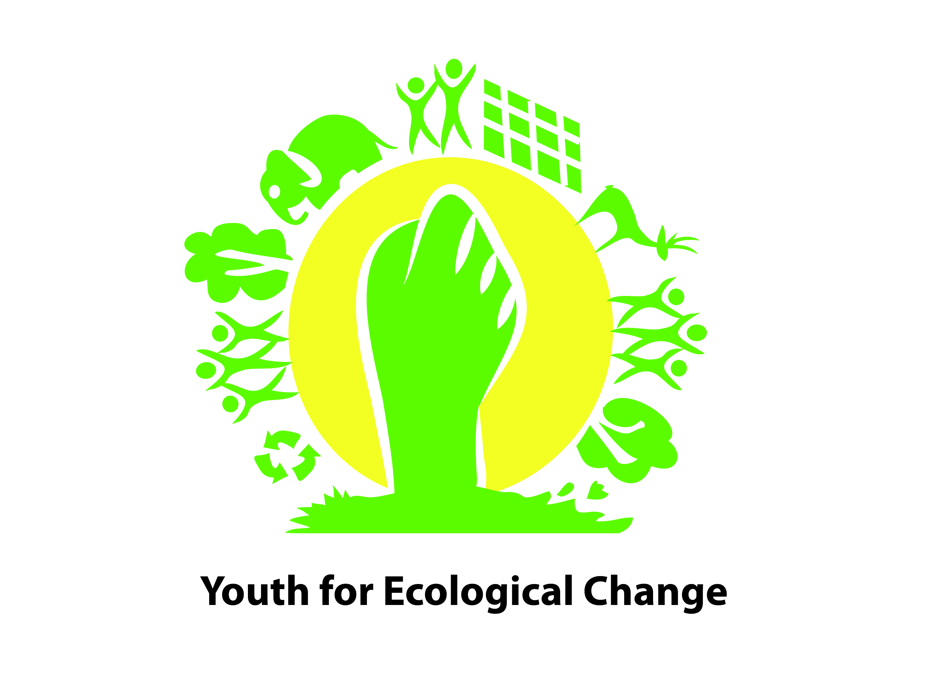

Charter for Ecological Rights of the Youth
We, 84 youth and children participating in 2nd Youth Convention on Ecological Rights November 2014, on the theme ‘Ecological Rights for Today and Tomorrow’ being organized at Indian Social Institute Bengaluru Coming from 13 states and representing about 12000 youth and children presents the following Charter of Demands.
We, being the future citizens of India are endowed with the responsibility of contributing and securing our Country’s Development that is not only sustainable, but also responsive to our diverse culture, rich natural heritage and sensitive to gender, equity and principles of justice
Our ability to perform that vital duty is incumbent upon us being able to be nurtured with a healthy physical and mental development and remaining adequately connected to and well aware of our natural and cultural heritage.
However, the fast deteriorating quality of our environment and the poor status of our rights and access over ecological resources (land, water, air and biodiversity) and commons, dwindling exposure to our highly adaptive and strong traditional knowledge base and a gradually dwindling disconnection with our culture and nature, making us not only ill-equipped to ensure physical and mental development but also endangering our survival
To ensure these ecological rights, we demand (for the state and others) the following actions urgently
- A balanced industrial development and urbanization, keeping in harmony with nature and rights and requirements of youth and children
- A ban on privatization of our natural endowments to allow youth and children to have adequate access to nature and open spaces
- Enhance access and safeguarding the rights of indigenous communities and their youth over the natural resources viz. forests, land and marine resources in their areas and protect their traditional livelihoods.
- Make the farming eco, culture and youth-friendly
- Conserve and augment forest, biodiversity and promote indigenous species to provide youth a healthy environment, better nutrition and access to nature and wilderness for recreation and education
- Ensure provision of safe drinking water and sanitation in educational and recreational facilities and enable youth and children access to free flowing clean rivers, lakes and other water bodies
- Reduce, reuse and recycle Waste and control Pollution to enable youth and children live a healthy environment and have balanced physical and mental development
Being conscious of our duties, while asking for our ecological rights, we also pledge
- To build institutions of youth at local, state and national level and connect to the international networks to share and exchange threats, best practices and options to ensure our ecological rights and engage with advocacy activities by acting as a pressure group
- To create examples by demonstrating small actions/initiatives in our own ways to protect nature and natural resources (viz. conserve/harvest water, plant/protect trees, conserve biodiversity etc.), adopt eco-friendly and climate-change adaptive practices (including no wasting of food, recycling our waste, reducing our foot prints and increasing our handprints etc.) as individuals, as youth groups/eco-clubs/bal-panchayats etc.
- To raise awareness on ecological balance and need of practising eco-friendly and climate-change adaptive practices among our neighborhoods and local communities through rallies, street plays, posters etc.
- To convey our demands for youth-sensitive policy and institutional framework for better connection with nature and natural resources free of pollution and ecological abuse to protect and maintain our ecological rights.
Bengaluru
3rd November 2014.

